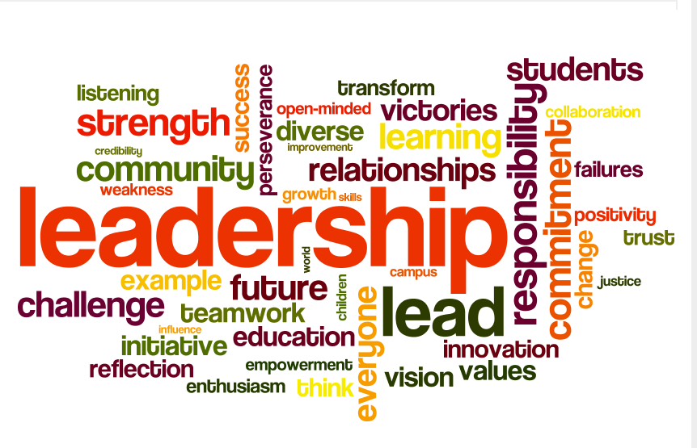
Developing Others as Leaders. There are four key areas where leaders need to be equally balanced. The fourth is learning to effectively develop other leaders. This area is more than just teaching others how to do the basics of Premier. To truly develop others, we must teach them how to develop themselves as leaders which includes teaching them how to develop leaders on their teams. This is where leaders get duplicated. The result of this is a large jewelry business! Use these trouble shooting questions to assess your how you develop others as leaders. The ultimate goal of a leader is to help develop the leaders around you!

‘—‘ Not confident in this area ‘+/-‘ I can do with effort but I’m not confident ‘+’ I so got this!

Do You ….. (These are two-fold. You must be developed in these areas so you can teach others! The second part to each is do you know how to teach your jewelers to do these)

_____ Lead by Example?

_____ Know who to work with on your team? Who to spend the most time with?

_____ Know great questions to start business conversations with your jewelers?

_____ Know how to help your jewelers see their potential and to help them see big?

_____ Know how to separate ministering to someone and truly helping her change her future by building a business?

_____ Know how to use the activity report to help someone see areas for growth and concern?

_____ Give opportunity for growth at trainings?

_____ Understand the difference in building and maintaining and how to see it in your jeweler’s business?

_____ Recognize your jewelers and teach them how to do the same?

_____ Work with your first levels and teach them how to work with their first levels?

_____ Feel confident in teaching your leaders how to start their own trainings or do smaller gatherings every other month?

_____ Feel confident in teaching your jewelers to share the plan and do an opportunity presentation?

_____ Spend time building others up through your words and actions?

_____ Know how to be kind but not nice while developing a new leader?

_____ Connect jewelers to others that can help them…maybe even more than you?

_____ Encourage your team to attend trainings and rallies and even help financial if the need arises?

_____ Have a system to take someone from jeweler to Designer?

Allison Mitchell and Tandy Flynn (5/1/2014)

